Pair Programming 2 Activities

* **Always use the pair programming tests to ensure your program works properly.**
* **Take a screen shot with a white background of each execution in the tests.**
* **Download the source code file for inclusion in the turn in document.**
* **Turn in pair programming activities using the pair programming turn in document.**
* **It is each individual’s responsibility to turn in the assignment and pair programming is graded individually so make sure you share the work you and your partner did together as you go.**
* **You can only earn 50% of pair programming points if you do not work with your partner.**
* **Do not share work with your partner that you did not do together.**
* **Make sure you have your partner’s name, username and contact information such as Pellissippi WebMail.**

2a. (1 point) Write a C++ program in a file called pp2a.cpp that uses a variable, x, that has been declared and initialized as shown here:

double x = 42.1298;

and uses output statements that print the output formatted as shown below using the variable x for the numbers 42, 42.1, and 42.13. You must use the functions cout.setf and cout.precision.

The answer to the question of

Life, the Universe, and Everything is 42, not 42.1

and not $42.13

2b. (2 points) With your partner, determine what the following expressions evaluate to. **Don’t use a calculator! Predict the answers on paper and record your predictions here BEFORE writing a program to check those predictions.**

int i = 3, j = 10;

double x = 9.9, y = -0.6;

|  |  |  |
| --- | --- | --- |
| __ i / j | ___ i % j | ___ j / i |
| ___ j % i | ___ x * i / j | ___ x * ( i / j) |
| ___ x / y + i | ___ j + y / x | ___ static_cast<double> (i) / j + y |

Then, write a C++ program in a file called pp2b.cpp with a main function that computes the values above and prints them. Remember to check the test document to ensure the program prints all output that is required.

1. Do the values you predicted match the output of your program?
2. If not, explain which ones are different and why.

2c. (3 points) Write a C++ program in a file called pp2c.cpp that implements an algorithm to print a message based upon a person’s age using the number line below. The program may either 1) print all of the messages that apply to the person or 2) print the single most recent message that applies to a person, for example, a person with age 26 would see only “You can rent a car”.

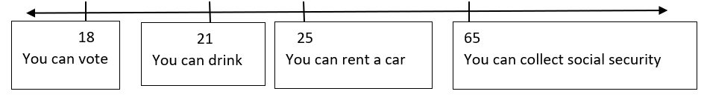

The number line is interpreted as follows: People 18 & over can vote; people 21 & over can drink alcohol; etc.

2d. (2 points) Write a C++ program in a file called pp2d.cpp that follows the algorithm below to assign a letter grade based upon a numeric grade that falls within one of the following ranges:

1. if grade is [93 and above]
   1. letterGrade = A
2. else if grade is between [83 and 93) *** The use of different symbols is NOT a typo.
   1. letterGrade = B *** [ ## means from & including the number
3. else if grade is between [73 and 83) *** ##] means up to & including
   1. letterGrade = C *** ##) means up to but NOT including
4. else if grade is between [65 and 73) *** (## means from but not including
   1. letterGrade = D
5. else
   1. letterGrade = F
6. Print letterGrade

2e. (2 points) Write a C++ program in a file called pp2e.cpp to ask the user if they are married or single. If they enter M or m (for married), print a creative, but polite message about marriage, such as “You entered married”. If they enter S or s, print a creative, but polite message about being single, such as “You entered single”. For any other character, print “Invalid marital status *x*” where *x* is the character the user entered. **Use a switch statement, not an if/else statement.** Refer to Chapter 3.2 of your textbook.

Your creative, polite messages should not match your partners. Don’t copy – that’s boring!